**Ideation Phase**

**Define the Problem Statement**

|  |  |
| --- | --- |
| Date | 19 September 2022 |
| Team ID | PNT2022TMID47600 |
| Project Name | Project –IOT based Real-Time River Water Quality Monitoring and Control System |
| Maximum Marks | 2 Marks |

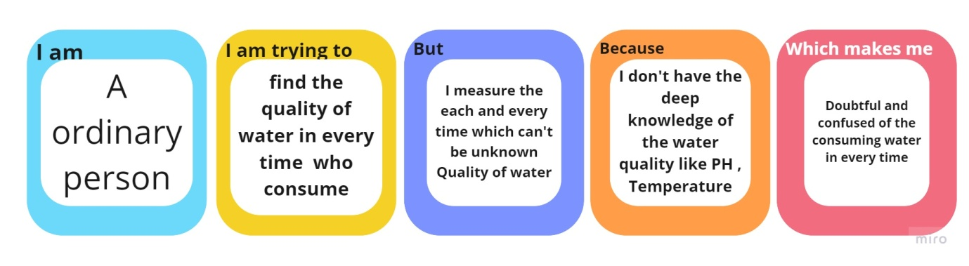

|  |  |  |
| --- | --- | --- |
| **I am** | Common people living a normal life on Earth | Common people living on Earth who consume water in their day-to-day life for different purpose |
| **I’m trying to** | Monitor the standard quality of the water | Wants to monitor the water consumed everyday whether the water is contaminated or pure, pH, temperature, salinity in it |
| **But** | Don’t know to monitor the quality of water | Time consuming a lot for process of manual testing |
| **Because** | Lack of required knowledge | Common people lack knowledge of this type of testing, sensors etc. |
| **Which makes me feel** | Doubted and fearful of the consumed water | Lack of pure water by changes in environment and also causing various diseases by bacteria and virus are present in water |